# Capstone-Engine API Documentation

V4.0.2

Official API document by [kabeor](https://github.com/kabeor)

Translated by Nitr0-G.

# Capstone Engine is a binary disassembly engine that supports multiple hardware architectures.

# 0x0 development preparation

**Capstone official website:** [**http://www.capstone-engine.org**](http://www.capstone-engine.org)

**Compile lib and dll methods by yourself**

**Source code:** [**https://github.com/capstone-engine/capstone.git**](https://github.com/capstone-engine/capstone.git)

**The file structure of git clone is as follows：**

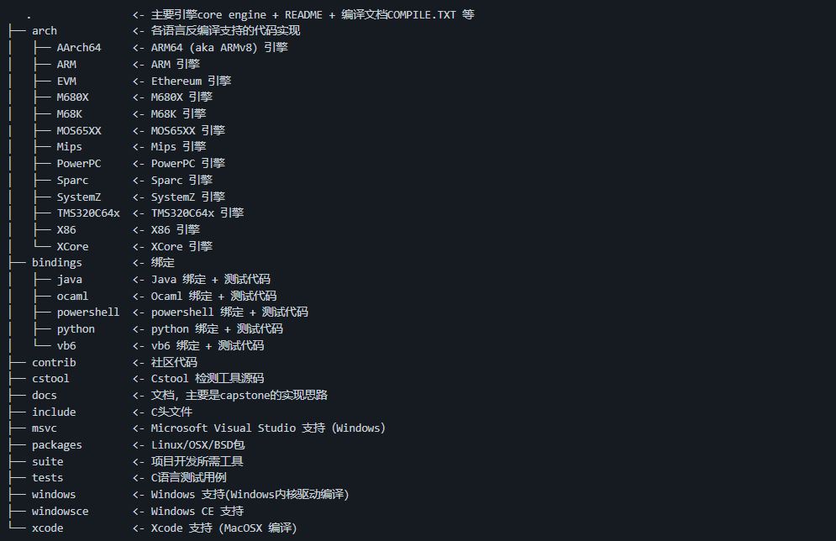

**The following demonstrates that Windows10 is compiled using Visual Studio2019**

**Copy the msvc folder to a more refreshing location, the internal structure is as follows：**

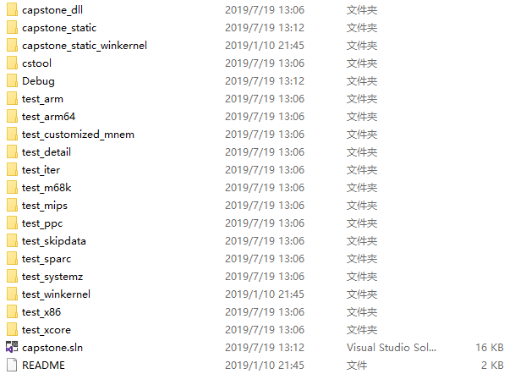

**;EU - VS open capstone.sln project files, the solution automatically loads these:**

**;RU – Откройте в VS capstone.sln и solution автоматически загрузит этоЖ**

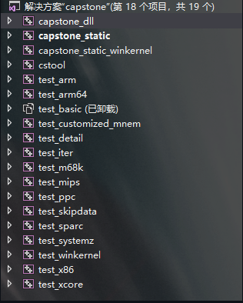

**;EU - You can see that all the supported languages are here. If you need them all, just compile them directly. Only a few of them are needed. Then right-click solution->Properties->Configure the properties as follows:**

**;RU - Вы можете видеть, что здесь представлены все поддерживаемые языки. Если они вам нужны все, просто скомпилируйте их напрямую. Нужны лишь некоторые из них. Затем щелкните правой кнопкой мыши solution->Properties->Настройте свойства следующим образом:**

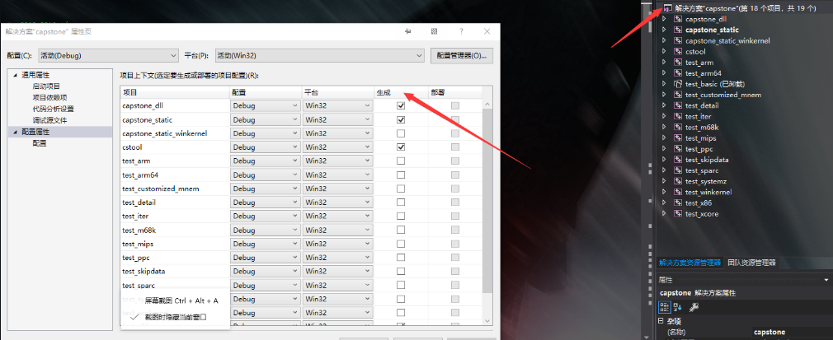

**;EU - Check the support items you need in the build options to compile and capstone will be generated in the Debug directory of the current folder.lib static compilation library and capstone.dll dynamic library so that you can start using Capstone for development.**

**;RU - Проверьте необходимые элементы поддержки в параметрах сборки для компиляции, и capstone будет сгенерирован в каталоге Debug текущей folder.lib статической компиляции lib и capstone.dll, чтобы вы могли начать использовать Capstone для разработки.**

**If you don't want to compile by yourself, the official compiled version is also provided**

**Win32： https://github.com/capstone-engine/capstone/releases/download/4.0.2/capstone-4.0.2-win32.zip**

**Win64： https://github.com/capstone-engine/capstone/releases/download/4.0.2/capstone-4.0.2-win64.zip**

**Choosing x32 or x64 will affect the number of digits developed later**

## Engine call test

**Create a new VS project, copy all the header files in capstone\include\capstone and the compiled lib and dll files to the home directory of the new project**

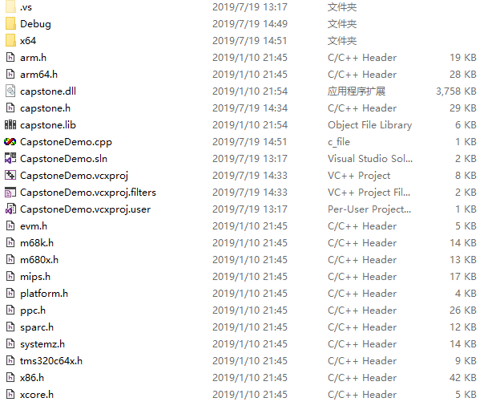

**In the VS solution, the header file adds the existing item capstone.h, add capstone to the resource file.lib, regenerate the solution**

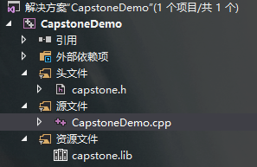

**So let's test our own capstone engine now**

**Write the following code to the main file**

**Code:**

#include <iostream>

#include <stdio.h>

#include <cinttypes>

#include "capstone.h"

using namespace std;

#define CODE "\x55\x48\x8b\x05\xb8\x13\x00\x00"

int main(void)

{

csh handle;

cs_insn* insn;

size_t count;

if (cs_open(CS_ARCH_X86, CS_MODE_64, &handle)) {

printf("ERROR: Failed to initialize engine!\n");

return -1;

}

count = cs_disasm(handle, (unsigned char*)CODE, sizeof(CODE) - 1, 0x1000, 0, &insn);

if (count) {

size_t j;

for (j = 0; j < count; j++) {

printf("0x%""Ix"":\t%s\t\t%s\n", insn[j].address, insn[j].mnemonic, insn[j].op_str);

}

cs_free(insn, count);

}

else

printf("ERROR: Failed to disassemble given code!\n");

cs_close(&handle);

return 0;

}

**Screen of code(is hidden):**

**Result:**

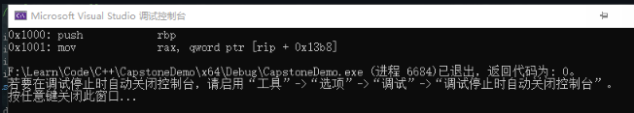

# 0x1 data type

## **csh**

**- Used to generate a handle to call the capstone API**

size_t csh

**Note: csh handle;**

## **cs_arch**

**-Architecture selection**

**Code:**

enum cs_arch {

CS_ARCH_ARM = 0, ///< ARM ( Thumb, Thumb-2)

CS_ARCH_ARM64, ///< ARM-64, AArch64

CS_ARCH_MIPS, ///< Mips

CS_ARCH_X86, ///< X86 ( x86 & x86-64)

CS_ARCH_PPC, ///< PowerPC

CS_ARCH_SPARC, ///< Sparc

CS_ARCH_SYSZ, ///< SystemZ

CS_ARCH_XCORE, ///< XCore

CS_ARCH_M68K, ///< 68K

CS_ARCH_TMS320C64X, ///< TMS320C64x

CS_ARCH_M680X, ///< 680X

CS_ARCH_EVM, ///< Ethereum

CS_ARCH_MAX,

CS_ARCH_ALL = 0xFFFF, // All architecture - for cs_support()

} cs_arch;

**Note: Fill in the enumeration content for the cs_arch parameter in the API, such as cs_open (cs_arch arch, cs_mode mode, csh *handle) in the API; fill in CS_ARCH_X86 for the first parameter to support the X86 architecture**

## **cs_mode**

**-** **Mode selection**

enum cs_mode {

CS_MODE_LITTLE_ENDIAN = 0, ///< little-endian 模式 (default 模式)

CS_MODE_ARM = 0, ///< 32-bit ARM

CS_MODE_16 = 1 << 1, ///< 16-bit 模式 (X86)

CS_MODE_32 = 1 << 2, ///< 32-bit 模式 (X86)

CS_MODE_64 = 1 << 3, ///< 64-bit 模式 (X86, PPC)

CS_MODE_THUMB = 1 << 4, ///< ARM's Thumb 模式, 包括 Thumb-2

CS_MODE_MCLASS = 1 << 5, ///< ARM's Cortex-M 系列

CS_MODE_V8 = 1 << 6, ///< ARMv8 A32解码方式

CS_MODE_MICRO = 1 << 4, ///< MicroMips 模式 (MIPS)

CS_MODE_MIPS3 = 1 << 5, ///< Mips III ISA

CS_MODE_MIPS32R6 = 1 << 6, ///< Mips32r6 ISA

CS_MODE_MIPS2 = 1 << 7, ///< Mips II ISA

CS_MODE_V9 = 1 << 4, ///< SparcV9 模式 (Sparc)

CS_MODE_QPX = 1 << 4, ///< Quad Processing eXtensions 模式 (PPC)

CS_MODE_SPE = 1 << 5, ///< Signal Processing Engine 模式 (PPC)

CS_MODE_BOOKE = 1 << 6, ///< Book-E 模式 (PPC)

CS_MODE_M68K_000 = 1 << 1, ///< M68K 68000 模式

CS_MODE_M68K_010 = 1 << 2, ///< M68K 68010 模式

CS_MODE_M68K_020 = 1 << 3, ///< M68K 68020 模式

CS_MODE_M68K_030 = 1 << 4, ///< M68K 68030 模式

CS_MODE_M68K_040 = 1 << 5, ///< M68K 68040 模式

CS_MODE_M68K_060 = 1 << 6, ///< M68K 68060 模式

CS_MODE_BIG_ENDIAN = 1 << 31, ///< big-endian 模式

CS_MODE_MIPS32 = CS_MODE_32, ///< Mips32 ISA (Mips)

CS_MODE_MIPS64 = CS_MODE_64, ///< Mips64 ISA (Mips)

CS_MODE_M680X_6301 = 1 << 1, ///< M680X Hitachi 6301,6303 模式

CS_MODE_M680X_6309 = 1 << 2, ///< M680X Hitachi 6309 模式

CS_MODE_M680X_6800 = 1 << 3, ///< M680X Motorola 6800,6802 模式

CS_MODE_M680X_6801 = 1 << 4, ///< M680X Motorola 6801,6803 模式

CS_MODE_M680X_6805 = 1 << 5, ///< M680X Motorola/Freescale 6805 模式

CS_MODE_M680X_6808 = 1 << 6, ///< M680X Motorola/Freescale/NXP 68HC08 模式

CS_MODE_M680X_6809 = 1 << 7, ///< M680X Motorola 6809 模式

CS_MODE_M680X_6811 = 1 << 8, ///< M680X Motorola/Freescale/NXP 68HC11 模式

CS_MODE_M680X_CPU12 = 1 << 9, ///< M680X Motorola/Freescale/NXP CPU12

///< 用于 M68HC12/HCS12

CS_MODE_M680X_HCS08 = 1 << 10, ///< M680X Freescale/NXP HCS08 模式

CS_MODE_BPF_CLASSIC = 0, ///< Classic BPF 模式 (默认)

CS_MODE_BPF_EXTENDED = 1 << 0, ///< Extended BPF 模式

CS_MODE_RISCV32 = 1 << 0, ///< RISCV RV32G

CS_MODE_RISCV64 = 1 << 1, ///< RISCV RV64G

CS_MODE_RISCVC = 1 << 2, ///< RISCV 压缩指令模式

CS_MODE_MOS65XX_6502 = 1 << 1, ///< MOS65XXX MOS 6502

CS_MODE_MOS65XX_65C02 = 1 << 2, ///< MOS65XXX WDC 65c02

CS_MODE_MOS65XX_W65C02 = 1 << 3, ///< MOS65XXX WDC W65c02

CS_MODE_MOS65XX_65816 = 1 << 4, ///< MOS65XXX WDC 65816, 8-bit m/x

CS_MODE_MOS65XX_65816_LONG_M = (1 << 5), ///< MOS65XXX WDC 65816, 16-bit m, 8-bit x

CS_MODE_MOS65XX_65816_LONG_X = (1 << 6), ///< MOS65XXX WDC 65816, 8-bit m, 16-bit x

CS_MODE_MOS65XX_65816_LONG_MX = CS_MODE_MOS65XX_65816_LONG_M | CS_MODE_MOS65XX_65816_LONG_X,

} cs_mode;

**Note: Fill in the enumeration content for the cs_mode parameter in the API, such as cs_open (cs_arch arch, cs_mode mode, csh *handle) in the API; fill in CS_MODE_64 for the second parameter to support X64 mode**

## cs_opt_mem

-Memory operation

struct cs_opt_mem {

cs_malloc_t malloc;

cs_calloc_t calloc;

cs_realloc_t realloc;

cs_free_t free;

cs_vsnprintf_t vsnprintf;

} cs_opt_mem;

Note: You can use the user-defined malloc/calloc/realloc/free/vsnprintf() function. By default, the system comes with malloc (), calloc(), realloc(), free() & vsnprintf().

## cs_opt_mnem

- Custom mnemonics

struct cs_opt_mnem {

/// Need a custom instruction ID

unsigned int id;

/// Custom mnemonics

const char *mnemonic;

} cs_opt_mnem;

## cs_opt_type

-Decompiled runtime options

enum cs_opt_type {

CS_OPT_INVALID = 0, //No special requirements

CS_OPT_SYNTAX, //Assembly output syntax

CS_OPT_DETAIL, //Break down the instruction structure into multiple details

CS_OPT_MODE, //Change engine mode at runtime

CS_OPT_MEM, //User-defined dynamic memory-related functions

CS_OPT_SKIPDATA, //Skip data when disassembling.Then the engine will be in SKIPDATA mode

CS_OPT_SKIPDATA_SETUP, //Set user-defined functions for the SKIPDATA option

CS_OPT_MNEMONIC, //Custom instruction mnemonics

CS_OPT_UNSIGNED, //Print immediate operands in unsigned form

} cs_opt_type;

**Not called in the currently open API**

## **cs_ac_type**

-Common instruction operand access types, consistent in all architectures, access types can be combined, for example: CS_AC_READ | CS_AC_WRITE

Code:

enum cs_ac_type {

CS_AC_INVALID = 0, //Uninitialized/invalid access type

CS_AC_READ = 1 << 0, //The operand is read from memory or register

CS_AC_WRITE = 1 << 1, //The operand is written from memory or register

} cs_ac_type;

Not called in the currently open API

## cs_group_type

- Common instruction set, consistent across all architectures

Code:

cs_group_type {

CS_GRP_INVALID = 0, //Uninitialized/invalid instruction set

CS_GRP_JUMP, //All jump instructions (conditional jump + direct jump + indirect jump)

CS_GRP_CALL, //All calling instructions

CS_GRP_RET, //All return instructions

CS_GRP_INT, //All interrupt instructions (INT+SYSCALL)

CS_GRP_IRET, //All interrupt return instructions

CS_GRP_PRIVILEGE, //All privileged instructions

CS_GRP_BRANCH_RELATIVE, //All relevant branch instructions

} cs_group_type;

Not called in the currently open API

## cs_opt_skipdata

-User-defined settings SKIPDATA options

Code:

struct cs_opt_skipdata {

/// CAPSTONE BELIEVES THAT THE DATA TO BE SKIPPED IS A SPECIAL "INSTRUCTION”

/// The user can specify the “mnemonic” string of the instruction here

/// By DEFAULT (@MNEMONIC is NULL), CAPSTONE USES “.BYTE”

const char *mnemonic;

/// User-DEFINED CALLBACK FUNCTION, CALLED when CAPSTONE HITS DATA

/// IF THE VALUE RETURNED BY THIS CALLBACK IS A POSITIVE number (>0), CAPSTONE WILL SKIP THIS NUMBER OF BYTES AND CONTINUE.If the callback returns 0, CAPSTONE will stop disassembling and immediately return from CS_DISASM()

/// Note: If THIS CALLBACK POINTER IS EMPTY, CAPSTONE WILL SKIP SOME BYTES ACCORDING TO THE ARCHITECTURE, AS SHOWN BELOW:

/// Arm: 2 bytes (Thumb mode) or 4 bytes.

/// Arm64: 4 bytes.

/// Mips: 4 bytes.

/// M680x: 1 byte.

/// PowerPC: 4 bytes.

/// Sparc: 4 bytes.

/// SystemZ: 2 bytes.

/// X86: 1 bytes.

/// XCore: 2 bytes.

/// EVM: 1 bytes.

/// RISCV: 4 bytes.

/// WASM: 1 bytes.

/// MOS65XX: 1 bytes.

/// BPF: 8 bytes.

cs_skipdata_cb_t callback; // The default value is NULL

/// User-defined data will be passed to the @CALLBACK function pointer

void *user_data;

} cs_opt_skipdata;

Not called in the currently open API

## cs_detail

-Note: All information in cs_detail is only available when CS_OPT_DETAIL = CS_OPT_ON

In arch/ARCH/ARCHDisassembler.The ARCH_getInstruction of c is initialized to memset (., 0, offsetof(cs_detail, ARCH)+sizeof(cs_ARCH))

If cs_detail changes, especially if a field is added after union, then update arch/arch/archdisassembly accordingly.c

Code:

struct cs_detail {

uint16_t regs_read[16]; ///< This parameter reads the list of implicit registers

uint8_t regs_read_count; ///< This parameter reads the implicit register count

uint16_t regs_write[20]; ///< This parameter modifies the list of implicit registers

uint8_t regs_write_count; ///< This parameter modifies the implicit register count

uint8_t groups[8]; ///< List of instruction groups to which this instruction belongs

uint8_t groups_count; ///< The number of groups to which this instruction belongs

/// Architecture-specific information

union {

cs_x86 x86; ///< X86, 16-bit, 32-bit & 64-bit

cs_arm64 arm64; ///< ARM64(aka AArch64)

cs_arm arm; ///< ARM(Thumb/Thumb2)

cs_m68k m68k; ///< M68K

cs_mips mips; ///< MIPS

cs_ppc ppc; ///< PowerPC

cs_sparc sparc; ///< Sparc

cs_sysz sysz; ///< SystemZ

cs_xcore xcore; ///< XCore

cs_tms320c64x tms320c64x; ///< TMS320C64x

cs_m680x m680x; ///< M680X

cs_evm evm; ///< Ethereum

cs_mos65xx mos65xx; ///< MOS65XX(MOS6502)

cs_wasm wasm; ///< Web Assembly

cs_bpf bpf; ///< Berkeley Packet Filter (eBPF)

cs_riscv riscv; ///< RISCV

};

} cs_detail;

## cs_insn

- Instruction details

Code:

struct cs_insn {

/// Instruction ID (basically a numeric ID used for instruction mnemonics)

/// The instruction ID IN'[ARCH]_INSN'ENUM SHOULD BE FOUND IN THE HEADER FILE OF THE CORRESPONDING architecture, SUCH AS ARM.The'ARM_INSN' in H represents ARM, X86.The 'X86_INSN' in H represents X86, ETC.…

/// This information can be used even when CS_OPT_DETAIL = CS_OPT_OFF

/// Note: In SKIPDATA mode, the “DATA” command for this ID field is 0

unsigned int id;

/// Instruction address (EIP)

/// This information can be used even when CS_OPT_DETAIL = CS_OPT_OFF

uint64_t address;

/// Instruction length

/// This information can be used even when CS_OPT_DETAIL = CS_OPT_OFF

uint16_t size;

/// The machine code of this instruction, the number of bytes is represented by the @SIZE above

/// This information can be used even when CS_OPT_DETAIL = CS_OPT_OFF

uint8_t bytes[24];

/// ASCII text mnemonic for instructions

/// This information can be used even when CS_OPT_DETAIL = CS_OPT_OFF

char mnemonic[CS_MNEMONIC_SIZE];

/// ASCII text for instruction operands

/// This information can be used even when CS_OPT_DETAIL = CS_OPT_OFF

char op_str[160];

/// CS_DETAIL pointer

/// Note: The DETAIL pointer is only valid if the following two requirements are met at the same time:

/// (1) CS_OP_DETAIL = CS_OPT_ON

/// (2) The engine is not in SKIPDATA mode (the CS_OP_SKIPDATA option is set to CS_OPT_ON)

/// Note 2: When in SKIPDATA mode or DETAIL mode is turned off, even if this pointer is not NULL, its content is still irrelevant.

cs_detail *detail;

} cs_insn;

## cs_err

-The return value of cs_errno() for various types of errors encountered by the Capstone API

Code:

typedef enum cs_err {

CS_ERR_OK = 0, ///< No error

CS_ERR_MEM, ///< Insufficient memory: CS_OPEN(), CS_DISASM(), CS_DISASM_ITER()

CS_ERR_ARCH, ///< Unsupported architecture: CS_OPEN()

CS_ERR_HANDLE, ///< The handle is not available: CS_OP_DATA(), CS_OP_INDEX()

CS_ERR_CSH, //CSH parameters are not available: CS_CLOSE(), CS_ERRNO(), CS_OPTION()

CS_ERR_MODE, ///< Invalid or unsupported mode: CS_OPEN()

CS_ERR_OPTION, ///< Invalid or unsupported options: CS_OPTION()

CS_ERR_DETAIL, ///< The information is not available because the DETAIL option is turned off

CS_ERR_MEMSETUP, //Dynamic memory management is not initialized (see CS_OPT_MEM)

CS_ERR_VERSION, ///< UNSUPPORTED version (BINDINGS)

CS_ERR_DIET, ///< Access irrelevant data in the ”DIET" engine

CS_ERR_SKIPDATA, ///< Access data unrelated to the “Data” instruction in SKIPDATA mode

CS_ERR_X86_ATT, ///< X86 AT&T syntax is not supported (exit at compile time)

CS_ERR_X86_INTEL, ///< X86 INTEL syntax is not supported (exit at compile time)

CS_ERR_X86_MASM, ///< X86 INTEL syntax is not supported (exit at compile time)

} cs_err;

# 0x2 API

## cs_version

unsigned int CAPSTONE_API cs_version(int *major, int *minor);

Used to output the capstone version number:

Major: API main version

Minor: API minor version

Return: Returns the hexadecimal of the primary and secondary versions, such as version 4.0 returns 0x0400

This version is defined in cs.In c, it cannot be changed after compilation, and custom versions are not accepted

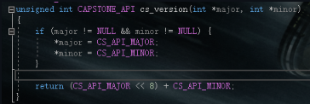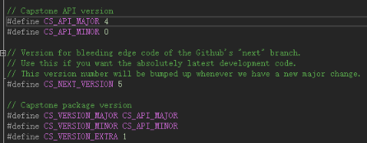

Code:

#include <stdio.h>

#include <stdlib.h>

#include "platform.h"

#include "capstone.h"

static int test()

{

return cs_version(NULL, NULL);

}

int main()

{

int version = test();

printf("%X", version);

return 0;

}

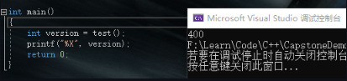

Example 2, forcibly modify the version:

#include <stdio.h>

#include <stdlib.h>

#include "platform.h"

#include "capstone.h"

static int test()

{

int ma[] = { 5 };

int mi[] = { 6 };

return cs_version(ma, mi);

}

int main()

{

int version = test();

printf("%X", version);

return 0;

}

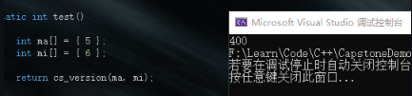

Visible and cannot be changed

## cs_support

bool CAPSTONE_API cs_support(int query);

Used to check whether the capstone library supports the architecture of parameter input or is in a certain compilation option

Code:

bool CAPSTONE_API cs_support(int query)

{

if (query == CS_ARCH_ALL)

return all_arch == ((1 << CS_ARCH_ARM) | (1 << CS_ARCH_ARM64) |

(1 << CS_ARCH_MIPS) | (1 << CS_ARCH_X86) |

(1 << CS_ARCH_PPC) | (1 << CS_ARCH_SPARC) |

(1 << CS_ARCH_SYSZ) | (1 << CS_ARCH_XCORE) |

(1 << CS_ARCH_M68K) | (1 << CS_ARCH_TMS320C64X) |

(1 << CS_ARCH_M680X) | (1 << CS_ARCH_EVM));

if ((unsigned int)query < CS_ARCH_MAX)

return all_arch & (1 << query);

if (query == CS_SUPPORT_DIET) {

#ifdef CAPSTONE_DIET

return true;

#else

return false;

#endif

}

if (query == CS_SUPPORT_X86_REDUCE) {

#if defined(CAPSTONE_HAS_X86) && defined(CAPSTONE_X86_REDUCE)

return true;

#else

return false;

#endif

}

// unsupported query

return false;

}

Example 1 (CS_ARCH_ALL, check whether all architectures are supported)

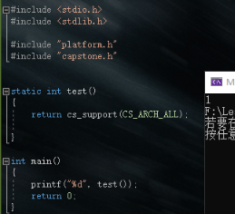

Example 2 (CS_ARCH_*, check whether the specified architecture is supported) 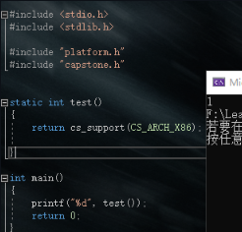

Example 3 (check if it is in DIET compilation mode)：

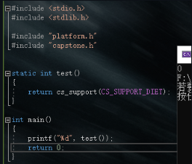

Example 4 (check if it is in X86_REDUCE compilation mode):

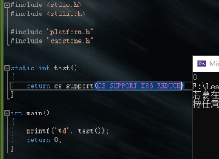

## cs_malloc_t

void* (CAPSTONE_API *cs_malloc_t)(size_t size);

Dynamic memory allocation of cs, used for

struct cs_opt_mem {

cs_malloc_t malloc;

cs_calloc_t calloc;

cs_realloc_t realloc;

cs_free_t free;

cs_vsnprintf_t vsnprintf;

} cs_opt_mem;

In user mode, cs_mem_malloc uses system malloc by default

In Windows driver mode, cs_malloc_t cs_mem_malloc = cs_winkernel_malloc;

cs_winkernel_malloc is defined in \capstone-4.0.1\windows\winkernel_mm.c,

Code:

void * CAPSTONE_API cs_winkernel_malloc(size_t size)

{

// 长度不能分配为0

NT_ASSERT(size);

// FP; NonPagedPool用于支持 Windows 7

#pragma prefast(suppress : 30030) // 分配可执行的POOL_TYPE内存

size_t number_of_bytes = 0;

CS_WINKERNEL_MEMBLOCK *block = NULL;

// 特定的值能造成溢出

// 如果value中的和超出或低于类型容量，函数将返回NULL。

if (!NT_SUCCESS(RtlSizeTAdd(size, sizeof(CS_WINKERNEL_MEMBLOCK), &number_of_bytes))) {

return NULL;

}

block = (CS_WINKERNEL_MEMBLOCK *)ExAllocatePoolWithTag(

NonPagedPool, number_of_bytes, CS_WINKERNEL_POOL_TAG);

if (!block) {

return NULL;

}

block->size = size;

return block->data;

}

In OSX kernel mode, cs_malloc_t cs_mem_malloc = kern_os_malloc;, will not be discussed here for the time being.

## cs_calloc_t

void* (CAPSTONE_API *cs_calloc_t)(size_t nmemb, size_t size);

cs applies for memory and initializes

Used for struct cs_opt_mem, defined in cs.c

User mode: cs_calloc_t cs_mem_calloc = calloc;, use system calloc

Windows driver mode: cs_calloc_t cs_mem_calloc = cs_winkernel_calloc;

Code:

void * CAPSTONE_API cs_winkernel_calloc(size_t n, size_t size)

{

size_t total = n * size;

void *new_ptr = cs_winkernel_malloc(total);

if (!new_ptr) {

return NULL;

}

return RtlFillMemory(new_ptr, total, 0);

}

OSX kernel mode: cs_calloc_t cs_mem_calloc = cs_kern_os_calloc; directly call kern_os_malloc

## cs_realloc_t

void* (CAPSTONE_API *cs_realloc_t)(void *ptr, size_t size);

cs reallocates memory

Used for struct cs_opt_mem, defined in cs.c

User mode: cs_realloc_t cs_mem_realloc= realloc;, call the system realloc

Windows driver mode: cs_realloc_t cs_mem_realloc = cs_winkernel_realloc;

Code:

void * CAPSTONE_API cs_winkernel_realloc(void *ptr, size_t size)

{

void *new_ptr = NULL;

size_t current_size = 0;

size_t smaller_size = 0;

if (!ptr) {

return cs_winkernel_malloc(size);

}

new_ptr = cs_winkernel_malloc(size);

if (!new_ptr) {

return NULL;

}

current_size = CONTAINING_RECORD(ptr, CS_WINKERNEL_MEMBLOCK, data)->size;

smaller_size = (current_size < size) ? current_size : size;

RtlCopyMemory(new_ptr, ptr, smaller_size);

cs_winkernel_free(ptr);

return new_ptr;

}

OSX kernel mode: cs_realloc_t cs_mem_realloc = kern_os_realloc;

## cs_free_t

typedef void (CAPSTONE_API *cs_free_t)(void *ptr);

cs frees up memory

Used for struct cs_opt_mem, defined in cs.c

User mode: cs_free_t cs_mem_free =free;, call the system free

Windows driver mode: cs_free_t cs_mem_free = cs_winkernel_free;

void CAPSTONE_API cs_winkernel_free(void *ptr)

{

if (ptr) {

ExFreePoolWithTag(CONTAINING_RECORD(ptr, CS_WINKERNEL_MEMBLOCK, data), CS_WINKERNEL_POOL_TAG);

}

}

OSX kernel mode: cs_free_t cs_mem_free = kern_os_free;

## cs_vsnprintf_t

int (CAPSTONE_API *cs_vsnprintf_t)(char *str, size_t size, const char *format, va_list ap);

Output to the string str by size

if the system is wince, the _vsnprintf function will be used

vsnprintf () and _vsnprintf() are both available for drivers, but they have some differences

Use vsnprintf() when you need to return a value and set a null terminator

Windows driver mode: cs_vsnprintf_t cs_vsnprintf = cs_winkernel_vsnprintf;

int CAPSTONE_API cs_winkernel_vsnprintf(char *buffer, size_t count, const char *format, va_list argptr)

{

int result = _vsnprintf(buffer, count, format, argptr);

// _vsnprintf()Returns -1 when the string is truncated, and “COUNT” when the entire string is stored but there is no “\0” at the end of “BUFFER”.In both cases, you need to manually add a null terminator.

if (result == -1 || (size_t)result == count) {

buffer[count - 1] = '\0';

}

if (result == -1) {

// When returning -1, the function must obtain and return some characters that were originally to be written.THEREFORE, BY RETRY USING THE TEMP BUFFER FOR THE SAME CONVERSION, THIS BUFFER MAY BE LARGE ENOUGH TO COMPLETE THE FORMATTING AND GET A LOT OF CHARACTERS THAT SHOULD HAVE BEEN WRITTEN.

char* tmp = cs_winkernel_malloc(0x1000);

if (!tmp) {

return result;

}

result = _vsnprintf(tmp, 0x1000, format, argptr);

NT_ASSERT(result != -1);

cs_winkernel_free(tmp);

}

return result;

}

OSX kernel mode: cs_vsnprintf_t cs_vsnprintf= vsnprintf;, use the default vsnprintf

## cs_skipdata_cb_t

size_t (CAPSTONE_API *cs_skipdata_cb_t)(const uint8_t *code, size_t code_size, size_t offset, void *user_data);

User-defined callback function for the SKIPDATA option.

Code: The input buffer that contains the code to be decomposed.Same as the buffer passed to cs_disasm().

code_size: The size of the code buffer above (in bytes).

offset: The position of the current check byte in the input buffer code mentioned above.

user_data: User data is passed to cs_option() through the @user_data field in the cs_opt_skipdata structure.

Return: Returns the number of bytes to be skipped, or 0 means that disassembly is stopped immediately.

cs_skipdata_cb_t is called in struct cs_opt_skipdata

### Code:

#include <stdio.h>

#include <stdlib.h>

#include "platform.h"

#include "capstone.h"

struct platform {

cs_arch arch;

cs_mode mode;

unsigned char* code;

size_t size;

const char* comment;

cs_opt_type opt_type;

cs_opt_value opt_value;

cs_opt_type opt_skipdata;

size_t skipdata;

};

static void print_string_hex(unsigned char* str, size_t len) //Output machine code

{

unsigned char* c;

printf("Code: ");

for (c = str; c < str + len; c++) {

printf("0x%02x ", *c & 0xff);

}

printf("\n");

}

static void test()

{

#define X86_CODE32 "\x8d\x4c\x32\x08\x01\xd8\x81\xc6\x34\x12\x00\x00\x00\x91\x92" // //Machine code for testing

#define RANDOM_CODE "\xed\x00\x00\x00\x00\x1a\x5a\x0f\x1f\xff\xc2\x09\x80\x00\x00\x00\x07\xf7\xeb\x2a\xff\xff\x7f\x57\xe3\x01\xff\xff\x7f\x57\xeb\x00\xf0\x00\x00\x24\xb2\x4f\x00\x78"

cs_opt_skipdata skipdata = {

// Change the default "DATA" descriptor from ".Rename "BYTE" To "DB" "DB", };

struct platform platforms[2] = { //Create an array in two ways: default descriptors and custom descriptors

{

CS_ARCH_X86,

CS_MODE_32,

(unsigned char*)X86_CODE32,

sizeof(X86_CODE32) - 1,

"X86 32 (Intel syntax) - Skip data",

},

{

CS_ARCH_X86,

CS_MODE_32,

(unsigned char*)X86_CODE32,

sizeof(X86_CODE32) - 1,

"X86 32 (Intel syntax) - Skip data with custom mnemonic",

CS_OPT_INVALID,

CS_OPT_OFF,

CS_OPT_SKIPDATA_SETUP,

(size_t)& skipdata,

},

};

csh handle; // Create a CAPSTONE handle

uint64_t address = 0x1000; // Set the starting address

cs_insn* insn; // Specific information structure

cs_err err; //Error enumeration

int i;

size_t count; //Number of successfully disassembled lines

for (i = 0; i < sizeof(platforms) / sizeof(platforms[0]); i++) {

printf("****************\n");

printf("Platform: %s\n", platforms[i].comment);

err = cs_open(platforms[i].arch, platforms[i].mode, &handle); //Error checking

if (err) {

printf("Failed on cs_open() with error returned: %u\n", err);

abort();

}

if (platforms[i].opt_type)

cs_option(handle, platforms[i].opt_type, platforms[i].opt_value);

// Turn on SKIPDATA mode

cs_option(handle, CS_OPT_SKIPDATA, CS_OPT_ON);

cs_option(handle, platforms[i].opt_skipdata, platforms[i].skipdata);

count = cs_disasm(handle, platforms[i].code, platforms[i].size, address, 0, &insn);

if (count) {

size_t j;

print_string_hex(platforms[i].code, platforms[i].size);

printf("Disasm:\n");

for (j = 0; j < count; j++) { // Output assembly

printf("0x%" PRIx64 ":\t%s\t\t%s\n",

insn[j].address, insn[j].mnemonic, insn[j].op_str);

}

// Print the offset after the last line of code

printf("0x%" PRIx64 ":\n", insn[j - 1].address + insn[j - 1].size);

//Free up the memory requested by CS_DISASM()

cs_free(insn, count);

}

else {

printf("****************\n");

printf("Platform: %s\n", platforms[i].comment);

print_string_hex(platforms[i].code, platforms[i].size);

printf("ERROR: Failed to disasm given code!\n");

abort();

}

printf("\n");

cs_close(&handle);

}

}

int main()

{

test();

return 0;

}

The running result is as follows, the default.The byte data type is changed to the db descriptor

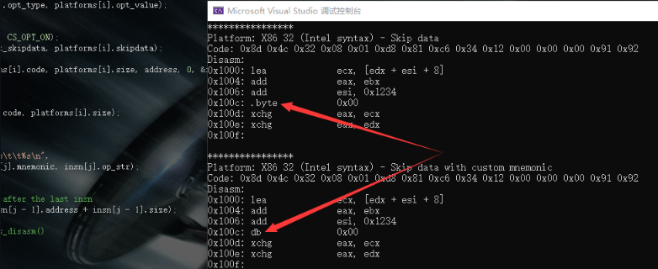

## cs_open

cs_err CAPSTONE_API cs_open(cs_arch arch, cs_mode mode, csh *handle);

Initialize the cs handle

arch: Architecture type (CS_ARCH_*)

Mode: hardware mode. CS_MODE_* can be found in the cs_mode data type

handle: Points to the handle, updated when returned

Return: CS_ERR_OK is returned after successful creation, otherwise the corresponding error message in the cs_err enumeration is returned

### Code:

cs_err CAPSTONE_API cs_open(cs_arch arch, cs_mode mode, csh *handle)

{

cs_err err;

struct cs_struct *ud;

if (!cs_mem_malloc || !cs_mem_calloc || !cs_mem_realloc || !cs_mem_free || !cs_vsnprintf)

// ERROR: Before using CS_OPEN(), you must use CS_OPTION(CS_OPT_MEM) to initialize dynamic //memory management

return CS_ERR_MEMSETUP;

if (arch < CS_ARCH_MAX && cs_arch_init[arch]) {

// Verify whether the architecture is used, method: The architecture is in the //enumeration and can be initialized

if (mode & cs_arch_disallowed_mode_mask[arch]) {

*handle = 0;

return CS_ERR_MODE;

}

ud = cs_mem_calloc(1, sizeof(*ud));

if (!ud) {

// Insufficient memory

return CS_ERR_MEM;

}

ud->errnum = CS_ERR_OK;

ud->arch = arch;

ud->mode = mode;

// By default, the command does not turn on the DETAIL mode

ud->detail = CS_OPT_OFF;

// Default SKIPDATA setting

ud->skipdata_setup.mnemonic = SKIPDATA_MNEM;

err = cs_arch_init[ud->arch](ud);

if (err) {

cs_mem_free(ud);

*handle = 0;

return err;

}

*handle = (uintptr_t)ud;

return CS_ERR_OK;

} else {

*handle = 0;

return CS_ERR_ARCH;

}

}

Among them, the cs_struct structure contains more detailed settings, as follows:

Code:

struct cs_struct {

cs_arch arch;

cs_mode mode;

Printer_t printer; // Print ASM

void *printer_info; // Print information

Disasm_t disasm; // Decompile

void *getinsn_info; // Print auxiliary information

GetName_t reg_name;

GetName_t insn_name;

GetName_t group_name;

GetID_t insn_id;

PostPrinter_t post_printer;

cs_err errnum;

ARM_ITStatus ITBlock; // ARM special options

cs_opt_value detail, imm_unsigned;

int syntax;// Basic ASM syntax printing for ARM, MIPS & PPC and other architectures

bool doing_mem; // Process memory operands in INSTPRINTER CODE

unsigned short *insn_cache; // FOR MAPPING.C Establish a cache index

GetRegisterName_t get_regname;

bool skipdata; // If you want to skip data when decompiling, set this item to TRUE

uint8_t skipdata_size; // The number of BYTES to skip

cs_opt_skipdata skipdata_setup; // Customize SKIPDATA settings

const uint8_t *regsize_map; // Map REGISTER size (currently only supports X86)

GetRegisterAccess_t reg_access;

struct insn_mnem *mnem_list; // List of links to custom instruction mnemonics

};

Example (create a cs handle of type x86_64)

cs_open(CS_ARCH_X86, CS_MODE_64, &handle)

## cs_close

cs_err CAPSTONE_API cs_close(csh *handle);

Release handle

handle: Points to a handle opened by cs_open()

Return: The release successfully returns CS_ERR_OK, otherwise the error message of cs_err_ok is returned

The essence of releasing the handle is to set the handle value to 0.

Code:

cs_err CAPSTONE_API cs_close(csh *handle)

{

struct cs_struct *ud;

struct insn_mnem *next, *tmp;

if (*handle == 0)

// Handle unavailable

return CS_ERR_CSH;

ud = (struct cs_struct *)(*handle);

if (ud->printer_info)

cs_mem_free(ud->printer_info);

// 释放自定义助记符的链接list

tmp = ud->mnem_list;

while(tmp) {

next = tmp->next;

cs_mem_free(tmp);

tmp = next;

}

cs_mem_free(ud->insn_cache);

memset(ud, 0, sizeof(*ud));

cs_mem_free(ud);

//The HANDLE value is set to 0 to ensure that this handle cannot be used after CS_CLOSE() //is released

*handle = 0;

return CS_ERR_OK;

}

Example

cs_close(&handle);

## cs_option

cs_err CAPSTONE_API cs_option(csh handle, cs_opt_type type, size_t value);

Runtime options for decompiling the engine

Handle: cs_open() Open handle

type: The type of setting option

Value: The option value corresponding to type

Return: The setting successfully returns CS_ERR_OK, otherwise the error message of cs_err_ok is returned

Note: In the case of CS_OPT_MEM, handle can be any value, so cs_option (handle, CS_OPT_MEM, value) must be called before cs_open()

### Code:

cs_err CAPSTONE_API cs_option(csh ud, cs_opt_type type, size_t value)

{

struct cs_struct *handle;

cs_opt_mnem *opt;

// Support support in front of all APIs (even cs_open())

if (type == CS_OPT_MEM) {

cs_opt_mem *mem = (cs_opt_mem *)value;

cs_mem_malloc = mem->malloc;

cs_mem_calloc = mem->calloc;

cs_mem_realloc = mem->realloc;

cs_mem_free = mem->free;

cs_vsnprintf = mem->vsnprintf;

return CS_ERR_OK;

}

handle = (struct cs_struct *)(uintptr_t)ud;

if (!handle)

return CS_ERR_CSH;

switch(type) {

default:

break;

case CS_OPT_UNSIGNED:

handle->imm_unsigned = (cs_opt_value)value;

return CS_ERR_OK;

case CS_OPT_DETAIL:

handle->detail = (cs_opt_value)value;

return CS_ERR_OK;

case CS_OPT_SKIPDATA:

handle->skipdata = (value == CS_OPT_ON);

if (handle->skipdata) {

if (handle->skipdata_size == 0) {

handle->skipdata_size = skipdata_size(handle);

}

}

return CS_ERR_OK;

case CS_OPT_SKIPDATA_SETUP:

if (value)

handle->skipdata_setup = *((cs_opt_skipdata *)value);

return CS_ERR_OK;

case CS_OPT_MNEMONIC:

opt = (cs_opt_mnem *)value;

if (opt->id) {

if (opt->mnemonic) {

struct insn_mnem *tmp;

// Add a new instruction or replace an existing instruction

// View the current INSN release in the LIST

tmp = handle->mnem_list;

while(tmp) {

if (tmp->insn.id == opt->id) {

// Find the instruction, replace the mnemonic

(void)strncpy(tmp->insn.mnemonic, opt->mnemonic, sizeof(tmp->insn.mnemonic) - 1);

tmp->insn.mnemonic[sizeof(tmp->insn.mnemonic) - 1] = '\0';

break;

}

tmp = tmp->next;

}

// 2. If not, add this instruction

if (!tmp) {

tmp = cs_mem_malloc(sizeof(*tmp));

tmp->insn.id = opt->id;

(void)strncpy(tmp->insn.mnemonic, opt->mnemonic, sizeof(tmp->insn.mnemonic) - 1);

tmp->insn.mnemonic[sizeof(tmp->insn.mnemonic) - 1] = '\0';

// The new command is placed at the top of the LIST

tmp->next = handle->mnem_list;

handle->mnem_list = tmp;

}

return CS_ERR_OK;

} else {

struct insn_mnem *prev, *tmp;

tmp = handle->mnem_list;

prev = tmp;

while(tmp) {

if (tmp->insn.id == opt->id) {

// Delete instruction

if (tmp == prev) {

handle->mnem_list = tmp->next;

} else {

prev->next = tmp->next;

}

cs_mem_free(tmp);

break;

}

prev = tmp;

tmp = tmp->next;

}

}

}

return CS_ERR_OK;

case CS_OPT_MODE:

// Verify that the requested pattern is valid

if (value & cs_arch_disallowed_mode_mask[handle->arch]) {

return CS_ERR_OPTION;

}

break;

}

return cs_arch_option[handle->arch](handle, type, value);

}

### Example, change the syntax displayed after disassembly

Code:

#include <iostream>

#include <stdio.h>

#include "capstone.h"

#include "platform.h"

using namespace std;

#define CODE "\x55\x48\x8b\x05\xb8\x13\x00\x00"

int main(void)

{

csh handle;

cs_insn* insn;

size_t count;

if (cs_open(CS_ARCH_X86, CS_MODE_64, &handle)) {

printf("ERROR: Failed to initialize engine!\n");

return -1;

}

cs_option(handle, CS_OPT_SYNTAX, CS_OPT_SYNTAX_ATT); // Displayed in AT&T syntax

count = cs_disasm(handle, (unsigned char*)CODE, sizeof(CODE) - 1, 0x1000, 0, &insn);

if (count) {

size_t j;

for (j = 0; j < count; j++) {

printf("0x%""Ix"":\t%s\t\t%s\n", insn[j].address, insn[j].mnemonic, insn[j].op_str);

}

cs_free(insn, count);

}

else

printf("ERROR: Failed to disassemble given code!\n");

cs_close(&handle);

return 0;

}

output

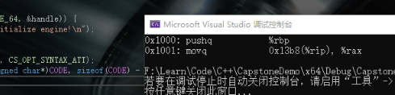

## cs_errno

An error message is returned when the API makes an error

Handle: cs_open() Open handle

Return: CS_ERR_OK is returned without error, otherwise the error message of cs_err_ok is returned

Judge that the handle does not exist and return CS_ERR_CSH directly

Code:

#include <iostream>

#include <stdio.h>

#include "capstone.h"

#include "platform.h"

using namespace std;

#define CODE "\x55\x48\x8b\x05\xb8\x13\x00\x00"

int main(void)

{

csh handle = 0;

cs_insn* insn;

size_t count;

if (cs_open(CS_ARCH_X86, CS_MODE_64, &handle)) {

printf("ERROR: Failed to initialize engine!\n");

return -1;

}

cs_close(&handle);

std::cout << cs_errno(handle); // After closing the handle, the check will report an error

return 0;

}

Output, error code 4 is CS_ERR_CSH



## cs_sterror

const char * CAPSTONE_API cs_strerror(cs_err code);

Convert the error code output from the previous API into a detailed error message

Code:

const char * CAPSTONE_API cs_strerror(cs_err code)

{

switch(code) {

default:

return "Unknown error code";

case CS_ERR_OK:

return "OK (CS_ERR_OK)";

case CS_ERR_MEM:

return "Out of memory (CS_ERR_MEM)";

case CS_ERR_ARCH:

return "Invalid/unsupported architecture(CS_ERR_ARCH)";

case CS_ERR_HANDLE:

return "Invalid handle (CS_ERR_HANDLE)";

case CS_ERR_CSH:

return "Invalid csh (CS_ERR_CSH)";

case CS_ERR_MODE:

return "Invalid mode (CS_ERR_MODE)";

case CS_ERR_OPTION:

return "Invalid option (CS_ERR_OPTION)";

case CS_ERR_DETAIL:

return "Details are unavailable (CS_ERR_DETAIL)";

case CS_ERR_MEMSETUP:

return "Dynamic memory management uninitialized (CS_ERR_MEMSETUP)";

case CS_ERR_VERSION:

return "Different API version between core & binding (CS_ERR_VERSION)";

case CS_ERR_DIET:

return "Information irrelevant in diet engine (CS_ERR_DIET)";

case CS_ERR_SKIPDATA:

return "Information irrelevant for 'data' instruction in SKIPDATA mode (CS_ERR_SKIPDATA)";

case CS_ERR_X86_ATT:

return "AT&T syntax is unavailable (CS_ERR_X86_ATT)";

case CS_ERR_X86_INTEL:

return "INTEL syntax is unavailable (CS_ERR_X86_INTEL)";

case CS_ERR_X86_MASM:

return "MASM syntax is unavailable (CS_ERR_X86_MASM)";

}

}

Example, used in combination with cs_errno:

Code:

#include <iostream>

#include <stdio.h>

#include "capstone.h"

#include "platform.h"

using namespace std;

#define CODE "\x55\x48\x8b\x05\xb8\x13\x00\x00"

int main(void)

{

csh handle = 0;

cs_insn* insn;

size_t count;

if (cs_open(CS_ARCH_X86, CS_MODE_64, &handle)) {

printf("ERROR: Failed to initialize engine!\n");

return -1;

}

cs_close(&handle);

std::cout << cs_strerror(cs_errno(handle)); // Directly output error message

return 0;

}

ouput



## cs_disasm

size_t CAPSTONE_API cs_disasm(csh handle,onst uint8_t *code, size_t code_size, uint64_t address, size_t count, cs_insn **insn);

Decompile the machine code given the buffer, size, address, and number

The API dynamically allocates memory to contain decomposed instructions, and the generated instructions will be placed in *insn

Note: The allocated memory must be released to avoid memory leaks.For systems that need to dynamically allocate scarce memory (such as OS kernel or firmware), API cs_disasm_iter() may be a better choice than cs_disasm().The reason is that when using cs_disasm(), based on the limited available memory, you must calculate in advance how many instructions to decompose.

Handle: The handle returned by cs_open()

Code: A buffer containing the machine code to be disassembled.

code_size: The size of the code buffer above.

Address: The address of the first instruction in the given original code buffer.

insn: An array of instructions filled in by this API.Note: insn will be allocated by this function and should be released with the cs_free () API

count: The number of instructions that need to be decomposed, or enter 0 to decompose all instructions

Return: The number of instructions successfully disassembled. If the function fails to disassemble the given code, it is 0. When it fails, call cs_errno() to get the error code.

### Code:

size_t CAPSTONE_API cs_disasm(csh ud, const uint8_t *buffer, size_t size, uint64_t offset, size_t count, cs_insn **insn)

{

struct cs_struct *handle;

MCInst mci;

uint16_t insn_size;

size_t c = 0, i;

unsigned int f = 0; // Index of the next instruction in the cache

cs_insn *insn_cache; // Cache disassembled instructions

void *total = NULL;

size_t total_size = 0; // The total size of the output buffer of all INSNS

bool r;

void *tmp;

size_t skipdata_bytes;

uint64_t offset_org; // Save all the original information of the buffer

size_t size_org;

const uint8_t *buffer_org;

unsigned int cache_size = INSN_CACHE_SIZE;

size_t next_offset;

handle = (struct cs_struct *)(uintptr_t)ud;

if (!handle) {

// Repair method:

// handle->errnum = CS_ERR_HANDLE;

return 0;

}

handle->errnum = CS_ERR_OK;

// Reset the IT BLOCK of ARM architecture

if (handle->arch == CS_ARCH_ARM)

handle->ITBlock.size = 0;

#ifdef CAPSTONE_USE_SYS_DYN_MEM

if (count > 0 && count <= INSN_CACHE_SIZE)

cache_size = (unsigned int) count;

#endif

// Save the original offset of SKIPDATA

buffer_org = buffer;

offset_org = offset;

size_org = size;

total_size = sizeof(cs_insn) * cache_size;

total = cs_mem_malloc(total_size);

if (total == NULL) {

// Insufficient memory

handle->errnum = CS_ERR_MEM;

return 0;

}

insn_cache = total;

while (size > 0) {

MCInst_Init(&mci);

mci.csh = handle;

mci.address = offset;

if (handle->detail) {

// Allocate memory to the DETAIL pointer

insn_cache->detail = cs_mem_malloc(sizeof(cs_detail));

} else {

insn_cache->detail = NULL;

}

// Save all information for NON-DETAILED mode

mci.flat_insn = insn_cache;

mci.flat_insn->address = offset;

#ifdef CAPSTONE_DIET

// MNEMONIC & OP_STR0 fill

mci.flat_insn->mnemonic[0] = '\0';

mci.flat_insn->op_str[0] = '\0';

#endif

r = handle->disasm(ud, buffer, size, &mci, &insn_size, offset, handle->getinsn_info);

if (r) {

SStream ss;

SStream_Init(&ss);

mci.flat_insn->size = insn_size;

// Map internal instruction opcodes to public INSN IDs

handle->insn_id(handle, insn_cache, mci.Opcode);

handle->printer(&mci, &ss, handle->printer_info);

fill_insn(handle, insn_cache, ss.buffer, &mci, handle->post_printer, buffer);

// Adjust OPCODE (X86)

if (handle->arch == CS_ARCH_X86)

insn_cache->id += mci.popcode_adjust;

next_offset = insn_size;

} else {

// Encountered an interrupt command

// Free up memory for the DETAIL pointer

if (handle->detail) {

cs_mem_free(insn_cache->detail);

}

if (!handle->skipdata || handle->skipdata_size > size)

break;

if (handle->skipdata_setup.callback) {

skipdata_bytes = handle->skipdata_setup.callback(buffer_org, size_org,

(size_t)(offset - offset_org), handle->skipdata_setup.user_data);

if (skipdata_bytes > size)

break;

if (!skipdata_bytes)

break;

} else

skipdata_bytes = handle->skipdata_size;

insn_cache->id = 0;

insn_cache->address = offset;

insn_cache->size = (uint16_t)skipdata_bytes;

memcpy(insn_cache->bytes, buffer, skipdata_bytes);

#ifdef CAPSTONE_DIET

insn_cache->mnemonic[0] = '\0';

insn_cache->op_str[0] = '\0';

#else

strncpy(insn_cache->mnemonic, handle->skipdata_setup.mnemonic,

sizeof(insn_cache->mnemonic) - 1);

skipdata_opstr(insn_cache->op_str, buffer, skipdata_bytes);

#endif

insn_cache->detail = NULL;

next_offset = skipdata_bytes;

}

// A new instruction enters the cache

f++;

// Disassembled an instruction

c++;

if (count > 0 && c == count)

break;

if (f == cache_size) {

cache_size = cache_size * 8 / 5;

total_size += (sizeof(cs_insn) * cache_size);

tmp = cs_mem_realloc(total, total_size);

if (tmp == NULL) { //内存不足

if (handle->detail) {

insn_cache = (cs_insn *)total;

for (i = 0; i < c; i++, insn_cache++)

cs_mem_free(insn_cache->detail);

}

cs_mem_free(total);

*insn = NULL;

handle->errnum = CS_ERR_MEM;

return 0;

}

total = tmp;

// Continue to fill the cache after the last instruction

insn_cache = (cs_insn *)((char *)total + sizeof(cs_insn) * c);

// Reset F to 0 and fill in the cache from the beginning

f = 0;

} else

insn_cache++;

buffer += next_offset;

size -= next_offset;

offset += next_offset;

}

if (!c) {

// No instructions have been disassembled

cs_mem_free(total);

total = NULL;

} else if (f != cache_size) {

// Did not fully use the last cache, reduce the size

tmp = cs_mem_realloc(total, total_size - (cache_size - f) * sizeof(*insn_cache));

if (tmp == NULL) { // Insufficient memory

// Release all DETAIL pointers

if (handle->detail) {

insn_cache = (cs_insn *)total;

for (i = 0; i < c; i++, insn_cache++)

cs_mem_free(insn_cache->detail);

}

cs_mem_free(total);

*insn = NULL;

handle->errnum = CS_ERR_MEM;

return 0;

}

total = tmp;

}

*insn = total;

return c;

}

### Example, x86_64

Code:

#include <iostream>

#include <stdio.h>

#include "capstone.h"

#include "platform.h"

using namespace std;

#define CODE "\x55\x48\x8b\x05\xb8\x13\x00\x00\xe9\xea\xbe\xad\xde\xff\x25\x23\x01\x00\x00\xe8\xdf\xbe\xad\xde\x74\xff"

int main(void)

{

csh handle = 0;

cs_insn* insn;

size_t count;

if (cs_open(CS_ARCH_X86, CS_MODE_64, &handle)) {

printf("ERROR: Failed to initialize engine!\n");

return -1;

}

count = cs_disasm(handle, (unsigned char*)CODE, sizeof(CODE) - 1, 0x1000, 0, &insn); // All instructions, base address 0X1000, put in INSN

if (count) {

size_t j;

for (j = 0; j < count; j++) {

printf("0x%""Ix"":\t%s\t\t%s\n", insn[j].address, insn[j].mnemonic, insn[j].op_str);

}

cs_free(insn, count);

}

else

printf("ERROR: Failed to disassemble given code!\n");

cs_close(&handle);

return 0;

}

output

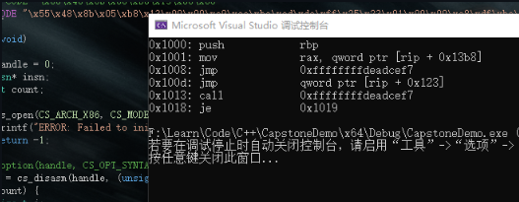

## cs_free

void CAPSTONE_API cs_free(cs_insn *insn, size_t count);

Release the memory allocated by cs_malloc() or cs_disasm() (insn parameter)

insn: Pointer returned by the @insn parameter in cs_disasm() or cs_malloc()

count: Assign the number of cs_insn structures returned by cs_disasm(), or assign a value of 1 to indicate the number of free memory allocated by cs_malloc()

Code:

void CAPSTONE_API cs_free(cs_insn *insn, size_t count)

{

size_t i;

// free 所有 detail 指针

for (i = 0; i < count; i++)

cs_mem_free(insn[i].detail);

cs_mem_free(insn);

}

Directly call cs_mem_free, which is the default free

Example (free up the memory requested by cs_disasm)

Code:

count = cs_disasm(handle, (unsigned char*)CODE, sizeof(CODE) - 1, 0x1000, 0, &insn); // Count the memory requested by CS_DISASM

if (count) {

size_t j;

for (j = 0; j < count; j++) {

printf("0x%""Ix"":\t%s\t\t%s\n", insn[j].address, insn[j].mnemonic, insn[j].op_str);

}

cs_free(insn, count); // The loop releases the memory of each INSN in turn

}

## cs_malloc

cs_insn * CAPSTONE_API cs_malloc(csh handle);

Is used to allocate memory for an instruction in API cs_disasm_iter()

Handle: The handle returned by cs_open()

Code:

cs_insn * CAPSTONE_API cs_malloc(csh ud)

{

cs_insn *insn;

struct cs_struct *handle = (struct cs_struct *)(uintptr_t)ud;

insn = cs_mem_malloc(sizeof(cs_insn));

if (!insn) {

// insufficient memory

handle->errnum = CS_ERR_MEM;

return NULL;

} else {

if (handle->detail) {

// allocate memory for @detail pointer

insn->detail = cs_mem_malloc(sizeof(cs_detail));

if (insn->detail == NULL) { // insufficient memory

cs_mem_free(insn);

handle->errnum = CS_ERR_MEM;

return NULL;

}

} else

insn->detail = NULL;

}

return insn;

}

When the memory occupied by this instruction is no longer used, use cs_free (insn, 1) to release it. The example is at cs_disasm_iter below.

## cs_disasm_iter

bool CAPSTONE_API cs_disasm_iter(csh handle,const uint8_t **code, size_t *size, uint64_t *address, cs_insn *insn);

Given the buff, size, address, and number of instructions to be decoded, to disassemble the machine code faster, this API puts the generated instructions into the given cache in insn.

Note 1: This API will update the code, size, and address to point to the next instruction in the input buffer.Therefore, although disassembling one instruction at a time can be achieved using cs_disasm(count=1), some benchmark tests show that using cs_disasm_iter() in a loop can easily iterate over all instructions quickly, and it can be 30% faster when randomly entered.

Note 2: You can use cs_malloc() to create a cache in insn.

Note 3: For systems that dynamically allocate memory that may produce insufficient memory (such as OS kernel or firmware), it is recommended to use the cs_disasm () API, because cs_disasm () allocates memory based on the number of instructions to be decomposed.

Handle: The handle returned by cs_open()

Code: The buffer where the machine code to be disassembled is located

Size: The size of the machine code buffer

Address: The address of the first insn in the given machine code buffer

insn: A pointer to the instruction to be populated by this API.

Return: If this API successfully disassembles an instruction, it returns true, otherwise it will return false.

When it fails, call cs_errno() to get the error code.

Code implementation, using dynamic memory allocation on the basis of cs_disasm

### Code:

bool CAPSTONE_API cs_disasm_iter(csh ud, const uint8_t **code, size_t *size,

uint64_t *address, cs_insn *insn)

{

struct cs_struct *handle;

uint16_t insn_size;

MCInst mci;

bool r;

handle = (struct cs_struct *)(uintptr_t)ud;

if (!handle) {

return false;

}

handle->errnum = CS_ERR_OK;

MCInst_Init(&mci);

mci.csh = handle;

mci.address = *address;

// Save relevant information for NO DETAIL mode

mci.flat_insn = insn;

mci.flat_insn->address = *address;

#ifdef CAPSTONE_DIET

mci.flat_insn->mnemonic[0] = '\0';

mci.flat_insn->op_str[0] = '\0';

#endif

r = handle->disasm(ud, *code, *size, &mci, &insn_size, *address, handle->getinsn_info);

if (r) {

SStream ss;

SStream_Init(&ss);

mci.flat_insn->size = insn_size;

// Map internal instruction opcodes to public INSN IDs

handle->insn_id(handle, insn, mci.Opcode);

handle->printer(&mci, &ss, handle->printer_info);

fill_insn(handle, insn, ss.buffer, &mci, handle->post_printer, *code);

// Adjust pseudo-opcode (X86)

if (handle->arch == CS_ARCH_X86)

insn->id += mci.popcode_adjust;

*code += insn_size;

*size -= insn_size;

*address += insn_size;

} else { // Encountered an interrupt command

size_t skipdata_bytes;

// If there is no request to skip the data, or the remaining data is too small, then exit

if (!handle->skipdata || handle->skipdata_size > *size)

return false;

if (handle->skipdata_setup.callback) {

skipdata_bytes = handle->skipdata_setup.callback(*code, *size,

0, handle->skipdata_setup.user_data);

if (skipdata_bytes > *size)

// The remaining data is too small

return false;

if (!skipdata_bytes)

return false;

} else

skipdata_bytes = handle->skipdata_size;

// Skip some data based on architecture and pattern

insn->id = 0; // The ID of this “data” instruction is invalid

insn->address = *address;

insn->size = (uint16_t)skipdata_bytes;

#ifdef CAPSTONE_DIET

insn->mnemonic[0] = '\0';

insn->op_str[0] = '\0';

#else

memcpy(insn->bytes, *code, skipdata_bytes);

strncpy(insn->mnemonic, handle->skipdata_setup.mnemonic,

sizeof(insn->mnemonic) - 1);

skipdata_opstr(insn->op_str, *code, skipdata_bytes);

#endif

*code += skipdata_bytes;

*size -= skipdata_bytes;

*address += skipdata_bytes;

}

return true;

}

### Code:

#include <iostream>

#include <stdio.h>

#include "capstone.h"

#include "platform.h"

using namespace std;

struct platform {

cs_arch arch;

cs_mode mode;

unsigned char* code;

size_t size;

const char* comment;

cs_opt_type opt_type;

cs_opt_value opt_value;

};

static void print_string_hex(unsigned char* str, size_t len)

{

unsigned char* c;

printf("Code: ");

for (c = str; c < str + len; c++) {

printf("0x%02x ", *c & 0xff);

}

printf("\n");

}

static void test()

{

#define X86_CODE16 "\x8d\x4c\x32\x08\x01\xd8\x81\xc6\x34\x12\x00\x00"

#define X86_CODE32 "\x8d\x4c\x32\x08\x01\xd8\x81\xc6\x34\x12\x00\x00"

#define X86_CODE64 "\x55\x48\x8b\x05\xb8\x13\x00\x00"

struct platform platforms[4] = { //Architecture and mode

{

CS_ARCH_X86,

CS_MODE_16,

(unsigned char*)X86_CODE16,

sizeof(X86_CODE32) - 1,

"X86 16bit (Intel syntax)"

},

{

CS_ARCH_X86,

CS_MODE_32,

(unsigned char*)X86_CODE32,

sizeof(X86_CODE32) - 1,

"X86 32bit (ATT syntax)",

CS_OPT_SYNTAX,

CS_OPT_SYNTAX_ATT,

},

{

CS_ARCH_X86,

CS_MODE_32,

(unsigned char*)X86_CODE32,

sizeof(X86_CODE32) - 1,

"X86 32 (Intel syntax)"

},

{

CS_ARCH_X86,

CS_MODE_64,

(unsigned char*)X86_CODE64,

sizeof(X86_CODE64) - 1,

"X86 64 (Intel syntax)"

},

csh handle;

uint64_t address;

cs_insn* insn;

cs_detail* detail;

int i;

cs_err err;

const uint8_t* code;

size_t size;

for (i = 0; i < sizeof(platforms) / sizeof(platforms[0]); i++) {

printf("****************\n");

printf("Platform: %s\n", platforms[i].comment);

err = cs_open(platforms[i].arch, platforms[i].mode, &handle);

if (err) {

printf("Failed on cs_open() with error returned: %u\n", err);

abort();

}

if (platforms[i].opt_type)

cs_option(handle, platforms[i].opt_type, platforms[i].opt_value);

cs_option(handle, CS_OPT_DETAIL, CS_OPT_ON);

// Allocate memory for CS_DISASM_ITER()

insn = cs_malloc(handle);

print_string_hex(platforms[i].code, platforms[i].size); // Original machine code

printf("Disasm:\n");

address = 0x1000;

code = platforms[i].code;

size = platforms[i].size;

while (cs_disasm_iter(handle, &code, &size, &address, insn)) {//CS_DISASM_ITER Disassembly int n;

printf("0x%" PRIx64 ":\t%s\t\t%s // insn-ID: %u, insn-mnem: %s\n",

insn->address, insn->mnemonic, insn->op_str,

insn->id, cs_insn_name(handle, insn->id));

// Print the implicit register used by this command

detail = insn->detail;

if (detail->regs_read_count > 0) {

printf("\tImplicit registers read: ");

for (n = 0; n < detail->regs_read_count; n++) {

printf("%s ", cs_reg_name(handle, detail->regs_read[n]));

}

printf("\n");

}

// Print the implicit register modified by this command

if (detail->regs_write_count > 0) {

printf("\tImplicit registers modified: ");

for (n = 0; n < detail->regs_write_count; n++) {

printf("%s ", cs_reg_name(handle, detail->regs_write[n]));

}

printf("\n");

}

// Print the instruction set to which this instruction belongs

if (detail->groups_count > 0) {

printf("\tThis instruction belongs to groups: ");

for (n = 0; n < detail->groups_count; n++) {

printf("%s ", cs_group_name(handle, detail->groups[n]));

}

printf("\n");

}

}

printf("\n");

// Free up the memory allocated by CS_MALLOC()

cs_free(insn, 1);

cs_close(&handle);

}

}

int main()

{

test();

return 0;

}

### output

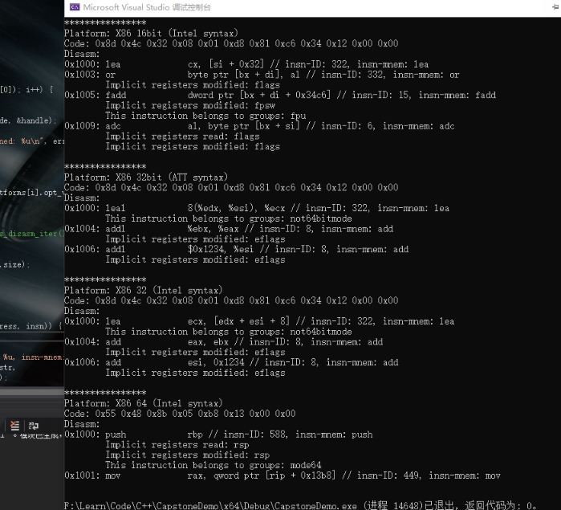

## cs_reg_name

const char * CAPSTONE_API cs_reg_name(csh handle, unsigned int reg_id);

Get the name of the register (string type) and the register id can be found in the header files of the relevant architecture (those header files copied to the project folder when the project is created)

Note: This API is not available when in diet mode because the engine does not store register names

Handle: The handle returned by cs_open()

reg_id: register id

Return: The character name of the register, return NULL if reg_id is not available

Code:

const char * CAPSTONE_API cs_reg_name(csh ud, unsigned int reg)

{

struct cs_struct *handle = (struct cs_struct *)(uintptr_t)ud;

if (!handle || handle->reg_name == NULL) {

return NULL;

}

return handle->reg_name(ud, reg);

}

Example (print RAX)

Code:

#include <iostream>

#include <stdio.h>

#include "capstone.h"

#include "platform.h"

using namespace std;

int main(void)

{

csh handle = 0;

cs_insn* insn;

size_t count;

if (cs_open(CS_ARCH_X86, CS_MODE_64, &handle)) {

printf("ERROR: Failed to initialize engine!\n");

return -1;

}

printf("%s", cs_reg_name(handle, X86_REG_RAX));

cs_close(&handle);

return 0;

}

output

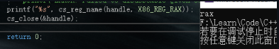

## cs_insn_name

const char * CAPSTONE_API cs_insn_name(csh handle, unsigned int insn_id);

Get the name of the instruction (string type)

The instruction id can be found in the header files of the relevant architecture (those header files copied to the project folder when the project is created)

Note: This API is not available when in diet mode because the engine does not store register names

Handle: The handle returned by cs_open()

insn_id: instruction id

return: The character name of the instruction, return NULL if insn_id is not available

Code:

const char * CAPSTONE_API cs_insn_name(csh ud, unsigned int insn)

{

struct cs_struct *handle = (struct cs_struct *)(uintptr_t)ud;

if (!handle || handle->insn_name == NULL) {

return NULL;

}

return handle->insn_name(ud, insn);

}

### Code#2:

#include <iostream>

#include <stdio.h>

#include "capstone.h"

#include "platform.h"

using namespace std;

struct platform {

cs_arch arch;

cs_mode mode;

unsigned char* code;

size_t size;

const char* comment;

cs_opt_type opt_type;

cs_opt_value opt_value;

};

static void print_string_hex(unsigned char* str, size_t len)

{

unsigned char* c;

printf("Code: ");

for (c = str; c < str + len; c++) {

printf("0x%02x ", *c & 0xff);

}

printf("\n");

}

static void test()

{

#define X86_CODE64 "\x55\x48\x8b\x05\xb8\x13\x00\x00\xe9\xea\xbe\xad\xde\xff\x25\x23\x01\x00\x00\xe8\xdf\xbe\xad\xde\x74\xff"

struct platform platforms[] = {

{

CS_ARCH_X86,

CS_MODE_64,

(unsigned char*)X86_CODE64,

sizeof(X86_CODE64) - 1,

"X86 64 (Intel syntax)"

},

};

csh handle;

uint64_t address;

cs_insn* insn;

cs_detail* detail;

int i;

cs_err err;

const uint8_t* code;

size_t size;

for (i = 0; i < sizeof(platforms) / sizeof(platforms[0]); i++) {

printf("****************\n");

printf("Platform: %s\n", platforms[i].comment);

err = cs_open(platforms[i].arch, platforms[i].mode, &handle);

if (err) {

printf("Failed on cs_open() with error returned: %u\n", err);

abort();

}

if (platforms[i].opt_type)

cs_option(handle, platforms[i].opt_type, platforms[i].opt_value);

cs_option(handle, CS_OPT_DETAIL, CS_OPT_ON);

insn = cs_malloc(handle);

print_string_hex(platforms[i].code, platforms[i].size);

printf("Disasm:\n");

address = 0x1000;

code = platforms[i].code;

size = platforms[i].size;

while (cs_disasm_iter(handle, &code, &size, &address, insn)) {

int n;

printf("0x%" PRIx64 ":\t%s\t\t%s",

insn->address, insn->mnemonic, insn->op_str);

printf(" instruction: %s", cs_insn_name(handle, insn->id)); // Output the operation instruction of the line

cout << endl;

printf("\n");

cs_free(insn, 1);

cs_close(&handle);

}

}

int main()

{

test();

return 0;

}

### output

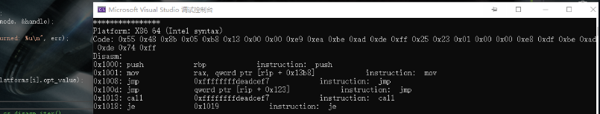

## cs_group_name

const char * CAPSTONE_API cs_group_name(csh handle, unsigned int group_id);

Output instruction type name

The instruction id can be found in the header files of the relevant architecture (those header files copied to the project folder when the project is created)

Note: This API is not available when in diet mode because the engine does not store register names

Handle: The handle returned by cs_open()

insn_id: instruction type id

return: The character name of the instruction type, return NULL if insn_id is not available

The examples are similar to the above, slightly.

## cs_insn_group

bool CAPSTONE_API cs_insn_group(csh handle, const cs_insn *insn, unsigned int group_id);

Check whether the disassembled instruction belongs to a specific instruction type

Note: This API is only available when the detail option is ON (OFF by default).

In "diet” mode, this API is useless because the engine does not update the insn->groups array

Handle: The handle returned by cs_open()

insn: Disassembly instruction structure received from cs_disasm() or cs_disasm_iter()

group_id: The type of instruction to check whether this instruction belongs to.

Return: True if the instruction does belong to the given instruction type, false otherwise.

Code:

bool CAPSTONE_API cs_insn_group(csh ud, const cs_insn *insn, unsigned int group_id)

{

struct cs_struct *handle;

if (!ud)

return false;

handle = (struct cs_struct *)(uintptr_t)ud;

if (!handle->detail) {

handle->errnum = CS_ERR_DETAIL;

return false;

}

if (!insn->id) {

handle->errnum = CS_ERR_SKIPDATA;

return false;

}

if (!insn->detail) {

handle->errnum = CS_ERR_DETAIL;

return false;

}

return arr_exist8(insn->detail->groups, insn->detail->groups_count, group_id);

}

Example (to determine whether it belongs to a jump instruction)

### Code:

#include <iostream>

#include <stdio.h>

#include "capstone.h"

#include "platform.h"

using namespace std;

struct platform {

cs_arch arch;

cs_mode mode;

unsigned char* code;

size_t size;

const char* comment;

cs_opt_type opt_type;

cs_opt_value opt_value;

};

static void print_string_hex(unsigned char* str, size_t len)

{

unsigned char* c;

printf("Code: ");

for (c = str; c < str + len; c++) {

printf("0x%02x ", *c & 0xff);

}

printf("\n");

}

static void test()

{

#define X86_CODE64 "\x55\x48\x8b\x05\xb8\x13\x00\x00\xe9\xea\xbe\xad\xde\xff\x25\x23\x01\x00\x00\xe8\xdf\xbe\xad\xde\x74\xff"

struct platform platforms[] = {

{

CS_ARCH_X86,

CS_MODE_64,

(unsigned char*)X86_CODE64,

sizeof(X86_CODE64) - 1,

"X86 64 (Intel syntax)"

},

};

csh handle;

uint64_t address;

cs_insn* insn;

cs_detail* detail;

int i;

cs_err err;

const uint8_t* code;

size_t size;

for (i = 0; i < sizeof(platforms) / sizeof(platforms[0]); i++) {

printf("****************\n");

printf("Platform: %s\n", platforms[i].comment);

err = cs_open(platforms[i].arch, platforms[i].mode, &handle);

if (err) {

printf("Failed on cs_open() with error returned: %u\n", err);

abort();

}

if (platforms[i].opt_type)

cs_option(handle, platforms[i].opt_type, platforms[i].opt_value);

cs_option(handle, CS_OPT_DETAIL, CS_OPT_ON);

insn = cs_malloc(handle);

print_string_hex(platforms[i].code, platforms[i].size);

printf("Disasm:\n");

address = 0x1000;

code = platforms[i].code;

size = platforms[i].size;

while (cs_disasm_iter(handle, &code, &size, &address, insn)) {

int n;

printf("0x%" PRIx64 ":\t%s\t\t%s ",

insn->address, insn->mnemonic, insn->op_str);

cout << "is JUMP: " <<cs_insn_group(handle, insn, CS_GRP_JUMP) << endl; // Determine whether it is a jump command

cout << endl;

printf("\n");

cs_free(insn, 1);

cs_close(&handle);

}

}

int main()

{

test();

return 0;

}

### output

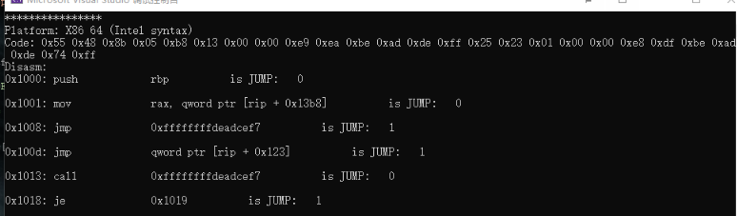

## cs_reg_read

bool CAPSTONE_API cs_reg_read(csh handle, const cs_insn *insn, unsigned int reg_id);

Check whether the disassembly instruction implicitly uses a specific register.

Note: This API is only valid when the detail option is enabled (the default is off)

In "diet" mode, this API is useless because the engine does not update the insn->regs_read array

insn: Disassembly instruction structure received from cs_disasm() or cs_disasm_iter()

reg_id: Mark whether the instruction you want to check uses it.

Return: True if the instruction does implicitly use the given register, otherwise false.

Code:

bool CAPSTONE_API cs_reg_read(csh ud, const cs_insn *insn, unsigned int reg_id)

{

struct cs_struct *handle;

if (!ud)

return false;

handle = (struct cs_struct *)(uintptr_t)ud;

if (!handle->detail) {

handle->errnum = CS_ERR_DETAIL;

return false;

}

if (!insn->id) {

handle->errnum = CS_ERR_SKIPDATA;

return false;

}

if (!insn->detail) {

handle->errnum = CS_ERR_DETAIL;

return false;

}

return arr_exist(insn->detail->regs_read, insn->detail->regs_read_count, reg_id);

}

The example is the same as API cs_disasm_iter

## cs_reg_write

bool CAPSTONE_API cs_reg_write(csh handle, const cs_insn *insn, unsigned int reg_id);

Check whether the disassembly instruction implicitly modifies a specific register.

Note: This API is only valid when the detail option is enabled (the default is off)

In "diet" mode, this API is useless because the engine does not update the insn->regs_read array

insn: Disassembly instruction structure received from cs_disasm() or cs_disasm_iter()

reg_id: Mark whether the instruction you want to check has modified it.

Return: True if the instruction does implicitly modify the given register, otherwise false.

Code:

bool CAPSTONE_API cs_reg_write(csh ud, const cs_insn *insn, unsigned int reg_id)

{

struct cs_struct *handle;

if (!ud)

return false;

handle = (struct cs_struct *)(uintptr_t)ud;

if (!handle->detail) {

handle->errnum = CS_ERR_DETAIL;

return false;

}

if (!insn->id) {

handle->errnum = CS_ERR_SKIPDATA;

return false;

}

if (!insn->detail) {

handle->errnum = CS_ERR_DETAIL;

return false;

}

return arr_exist(insn->detail->regs_write, insn->detail->regs_write_count, reg_id);

}

The example is the same as API cs_disasm_iter

## cs_op_count

int CAPSTONE_API cs_op_count(csh handle, const cs_insn *insn, unsigned int op_type);

Calculate the number of operands of a given type

Note: This API is only available when the detail option is ON (OFF by default).

Handle: The handle returned by cs_open()

insn: Disassembly instruction structure received from cs_disasm() or cs_disasm_iter()

op_type: The type of operand to be found.

Return: The number of operands of the given type op_type in the instruction insn, returning -1 indicates that the lookup failed.

### Code:

int CAPSTONE_API cs_op_count(csh ud, const cs_insn *insn, unsigned int op_type)

{

struct cs_struct *handle;

unsigned int count = 0, i;

if (!ud)

return -1;

handle = (struct cs_struct *)(uintptr_t)ud;

if (!handle->detail) {

handle->errnum = CS_ERR_DETAIL;

return -1;

}

if (!insn->id) {

handle->errnum = CS_ERR_SKIPDATA;

return -1;

}

if (!insn->detail) {

handle->errnum = CS_ERR_DETAIL;

return -1;

}

handle->errnum = CS_ERR_OK;

switch (handle->arch) {

default:

handle->errnum = CS_ERR_HANDLE;

return -1;

case CS_ARCH_ARM:

for (i = 0; i < insn->detail->arm.op_count; i++)

if (insn->detail->arm.operands[i].type == (arm_op_type)op_type)

count++;

break;

case CS_ARCH_ARM64:

for (i = 0; i < insn->detail->arm64.op_count; i++)

if (insn->detail->arm64.operands[i].type == (arm64_op_type)op_type)

count++;

break;

case CS_ARCH_X86:

for (i = 0; i < insn->detail->x86.op_count; i++)

if (insn->detail->x86.operands[i].type == (x86_op_type)op_type)

count++;

break;

case CS_ARCH_MIPS:

for (i = 0; i < insn->detail->mips.op_count; i++)

if (insn->detail->mips.operands[i].type == (mips_op_type)op_type)

count++;

break;

case CS_ARCH_PPC:

for (i = 0; i < insn->detail->ppc.op_count; i++)

if (insn->detail->ppc.operands[i].type == (ppc_op_type)op_type)

count++;

break;

case CS_ARCH_SPARC:

for (i = 0; i < insn->detail->sparc.op_count; i++)

if (insn->detail->sparc.operands[i].type == (sparc_op_type)op_type)

count++;

break;

case CS_ARCH_SYSZ:

for (i = 0; i < insn->detail->sysz.op_count; i++)

if (insn->detail->sysz.operands[i].type == (sysz_op_type)op_type)

count++;

break;

case CS_ARCH_XCORE:

for (i = 0; i < insn->detail->xcore.op_count; i++)

if (insn->detail->xcore.operands[i].type == (xcore_op_type)op_type)

count++;

break;

case CS_ARCH_M68K:

for (i = 0; i < insn->detail->m68k.op_count; i++)

if (insn->detail->m68k.operands[i].type == (m68k_op_type)op_type)

count++;

break;

case CS_ARCH_TMS320C64X:

for (i = 0; i < insn->detail->tms320c64x.op_count; i++)

if (insn->detail->tms320c64x.operands[i].type == (tms320c64x_op_type)op_type)

count++;

break;

case CS_ARCH_M680X:

for (i = 0; i < insn->detail->m680x.op_count; i++)

if (insn->detail->m680x.operands[i].type == (m680x_op_type)op_type)

count++;

break;

case CS_ARCH_EVM:

#if 0

for (i = 0; i < insn->detail->evm.op_count; i++)

if (insn->detail->evm.operands[i].type == (evm_op_type)op_type)

count++;

#endif

break;

}

return count;

}

### Example of x86 instruction opcode type (judgment register opcode)

Code:

typedef enum x86_op_type {

X86_OP_INVALID = 0, ///< = CS_OP_INVALID (Uninitialized).

X86_OP_REG, ///< = CS_OP_REG (Register opcode).

X86_OP_IMM, ///< = CS_OP_IMM (Opcode now).

X86_OP_MEM, ///< = CS_OP_MEM (Memory opcode).

} x86_op_type;

#include <iostream>

#include <stdio.h>

#include "capstone.h"

#include "platform.h"

using namespace std;

struct platform {

cs_arch arch;

cs_mode mode;

unsigned char* code;

size_t size;

const char* comment;

cs_opt_type opt_type;

cs_opt_value opt_value;

};

static void print_string_hex(unsigned char* str, size_t len)

{

unsigned char* c;

printf("Code: ");

for (c = str; c < str + len; c++) {

printf("0x%02x ", *c & 0xff);

}

printf("\n");

}

static void test()

{

#define X86_CODE64 "\x55\x48\x8b\x05\xb8\x13\x00\x00\xe9\xea\xbe\xad\xde\xff\x25\x23\x01\x00\x00\xe8\xdf\xbe\xad\xde\x74\xff"

struct platform platforms[] = {

{

CS_ARCH_X86,

CS_MODE_64,

(unsigned char*)X86_CODE64,

sizeof(X86_CODE64) - 1,

"X86 64 (Intel syntax)"

},

};

csh handle;

uint64_t address;

cs_insn* insn;

cs_detail* detail;

int i;

cs_err err;

const uint8_t* code;

size_t size;

for (i = 0; i < sizeof(platforms) / sizeof(platforms[0]); i++) {

printf("****************\n");

printf("Platform: %s\n", platforms[i].comment);

err = cs_open(platforms[i].arch, platforms[i].mode, &handle);

if (err) {

printf("Failed on cs_open() with error returned: %u\n", err);

abort();

}

if (platforms[i].opt_type)

cs_option(handle, platforms[i].opt_type, platforms[i].opt_value);

cs_option(handle, CS_OPT_DETAIL, CS_OPT_ON);

insn = cs_malloc(handle);

print_string_hex(platforms[i].code, platforms[i].size);

printf("Disasm:\n");

address = 0x1000;

code = platforms[i].code;

size = platforms[i].size;

while (cs_disasm_iter(handle, &code, &size, &address, insn)) {

int n;

printf("0x%" PRIx64 ":\t%s\t\t%s ",

insn->address, insn->mnemonic, insn->op_str);

cout << "is REG: " << cs_op_count(handle, insn, X86_OP_REG) << endl; // Determine whether it is a registered opcode

cout << endl;

printf("\n");

cs_free(insn, 1);

cs_close(&handle);

}

}

int main()

{

test();

return 0;

}

### output

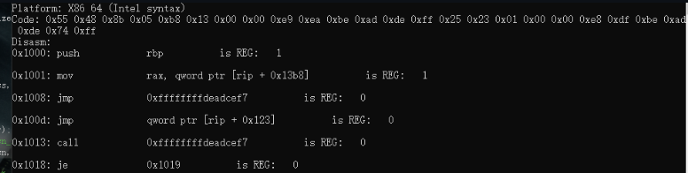

## cs_op_index

int CAPSTONE_API cs_op_index(csh handle, const cs_insn *insn, unsigned int op_type, unsigned int position);

Retrieve the operand of the given type in <arch>.The position in the operands[] array, use the returned position to access the operand

Note: This API is only available when the detail option is ON (OFF by default).

Handle: The handle returned by cs_open()

insn: Disassembly instruction structure received from cs_disasm() or cs_disasm_iter()

op_type: The type of operand to be found.

Position: The position of the operand to be found.The range must be within`[1, cs_op_data(handle, insn, op_type)]`

return:`<arch> of the instruction insn.operands[]'The index of the operand of the given type op_type in the array, returns -1 when it fails.

### Code:

int CAPSTONE_API cs_op_index(csh ud, const cs_insn *insn, unsigned int op_type,

unsigned int post)

{

struct cs_struct *handle;

unsigned int count = 0, i;

if (!ud)

return -1;

handle = (struct cs_struct *)(uintptr_t)ud;

if (!handle->detail) {

handle->errnum = CS_ERR_DETAIL;

return -1;

}

if (!insn->id) {

handle->errnum = CS_ERR_SKIPDATA;

return -1;

}

if (!insn->detail) {

handle->errnum = CS_ERR_DETAIL;

return -1;

}

handle->errnum = CS_ERR_OK;

switch (handle->arch) {

default:

handle->errnum = CS_ERR_HANDLE;

return -1;

case CS_ARCH_ARM:

for (i = 0; i < insn->detail->arm.op_count; i++) {

if (insn->detail->arm.operands[i].type == (arm_op_type)op_type)

count++;

if (count == post)

return i;

}

break;

case CS_ARCH_ARM64:

for (i = 0; i < insn->detail->arm64.op_count; i++) {

if (insn->detail->arm64.operands[i].type == (arm64_op_type)op_type)

count++;

if (count == post)

return i;

}

break;

case CS_ARCH_X86:

for (i = 0; i < insn->detail->x86.op_count; i++) {

if (insn->detail->x86.operands[i].type == (x86_op_type)op_type)

count++;

if (count == post)

return i;

}

break;

case CS_ARCH_MIPS:

for (i = 0; i < insn->detail->mips.op_count; i++) {

if (insn->detail->mips.operands[i].type == (mips_op_type)op_type)

count++;

if (count == post)

return i;

}

break;

case CS_ARCH_PPC:

for (i = 0; i < insn->detail->ppc.op_count; i++) {

if (insn->detail->ppc.operands[i].type == (ppc_op_type)op_type)

count++;

if (count == post)

return i;

}

break;

case CS_ARCH_SPARC:

for (i = 0; i < insn->detail->sparc.op_count; i++) {

if (insn->detail->sparc.operands[i].type == (sparc_op_type)op_type)

count++;

if (count == post)

return i;

}

break;

case CS_ARCH_SYSZ:

for (i = 0; i < insn->detail->sysz.op_count; i++) {

if (insn->detail->sysz.operands[i].type == (sysz_op_type)op_type)

count++;

if (count == post)

return i;

}

break;

case CS_ARCH_XCORE:

for (i = 0; i < insn->detail->xcore.op_count; i++) {

if (insn->detail->xcore.operands[i].type == (xcore_op_type)op_type)

count++;

if (count == post)

return i;

}

break;

case CS_ARCH_M68K:

for (i = 0; i < insn->detail->m68k.op_count; i++) {

if (insn->detail->m68k.operands[i].type == (m68k_op_type)op_type)

count++;

if (count == post)

return i;

}

break;

case CS_ARCH_TMS320C64X:

for (i = 0; i < insn->detail->tms320c64x.op_count; i++) {

if (insn->detail->tms320c64x.operands[i].type == (tms320c64x_op_type)op_type)

count++;

if (count == post)

return i;

}

break;

case CS_ARCH_M680X:

for (i = 0; i < insn->detail->m680x.op_count; i++) {

if (insn->detail->m680x.operands[i].type == (m680x_op_type)op_type)

count++;

if (count == post)

return i;

}

break;

}

return -1;

}

### Exapmle with program

Code:

#include <iostream>

#include <stdio.h>

#include "capstone.h"

#include "platform.h"

using namespace std;

struct platform {

cs_arch arch;

cs_mode mode;

unsigned char* code;

size_t size;

const char* comment;

cs_opt_type opt_type;

cs_opt_value opt_value;

};

static void print_string_hex(unsigned char* str, size_t len)

{

unsigned char* c;

printf("Code: ");

for (c = str; c < str + len; c++) {

printf("0x%02x ", *c & 0xff);

}

printf("\n");

}

static void test()

{

#define X86_CODE64 "\x55\x48\x8b\x05\xb8\x13\x00\x00\xe9\xea\xbe\xad\xde\xff\x25\x23\x01\x00\x00\xe8\xdf\xbe\xad\xde\x74\xff"

struct platform platforms[] = {

{

CS_ARCH_X86,

CS_MODE_64,

(unsigned char*)X86_CODE64,

sizeof(X86_CODE64) - 1,

"X86 64 (Intel syntax)"

},

};

csh handle;

uint64_t address;

cs_insn* insn;

cs_detail* detail;

int i;

cs_err err;

const uint8_t* code;

size_t size;

cs_x86* x86;

int count;

for (i = 0; i < sizeof(platforms) / sizeof(platforms[0]); i++) {

printf("****************\n");

printf("Platform: %s\n", platforms[i].comment);

err = cs_open(platforms[i].arch, platforms[i].mode, &handle);

if (err) {

printf("Failed on cs_open() with error returned: %u\n", err);

abort();

}

if (platforms[i].opt_type)

cs_option(handle, platforms[i].opt_type, platforms[i].opt_value);

cs_option(handle, CS_OPT_DETAIL, CS_OPT_ON);

insn = cs_malloc(handle);

x86 = &(insn->detail->x86);

print_string_hex(platforms[i].code, platforms[i].size);

printf("Disasm:\n");

address = 0x1000;

code = platforms[i].code;

size = platforms[i].size;

while (cs_disasm_iter(handle, &code, &size, &address, insn)) {

int n;

printf("0x%" PRIx64 ":\t%s\t\t%s ",

insn->address, insn->mnemonic, insn->op_str);

cout << endl;

count = cs_op_count(handle, insn, X86_OP_IMM); // Find immediate number

if (count) {

printf("\timm_count: %u\n", count);

for (i = 1; i < count + 1; i++) {

int index = cs_op_index(handle, insn, X86_OP_IMM, i);

printf("\timms[%u]: 0x%" PRIx64 "\n", i, x86->operands[index].imm);

if (x86->encoding.imm_offset != 0) {

printf("\timm_offset: 0x%x\n", x86->encoding.imm_offset);

}

if (x86->encoding.imm_size != 0) {

printf("\timm_size: 0x%x\n", x86->encoding.imm_size);

}

}

}

}

printf("\n");

cs_free(insn, 1);

cs_close(&handle);

}

}

int main()

{

test();

return 0;

}

### output

## cs_regs_access

cs_err CAPSTONE_API cs_regs_access(csh handle, const cs_insn *insn,

cs_regs regs_read, uint8_t *regs_read_count,

cs_regs regs_write, uint8_t *regs_write_count);

Retrieve all registers accessed explicitly or implicitly by an instruction

Note: In ”diet" mode, this API is not available because the engine does not store registers

Handle: The handle returned by cs_open()

insn: Disassembly instruction structure returned from cs_disasm() or cs_disasm_iter()

regs_read: When returned, this array contains all the registers read by the instruction.

regs_read_data: The number of registers stored in the regs_read array.

regs_write: When returned, this array contains all the registers modified by the instruction.

regs_write_data: The number of registers stored in the regs_write array.

CS_ERR_OK is returned on success, and other values are returned on failure (please refer to cs_err enum for detailed errors).

Code:

cs_err CAPSTONE_API cs_regs_access(csh ud, const cs_insn *insn,

cs_regs regs_read, uint8_t *regs_read_count,

cs_regs regs_write, uint8_t *regs_write_count)

{

struct cs_struct *handle;

if (!ud)

return -1;

handle = (struct cs_struct *)(uintptr_t)ud;

#ifdef CAPSTONE_DIET

// This API does not work in DIET mode

handle->errnum = CS_ERR_DIET;

return CS_ERR_DIET;

#else

if (!handle->detail) {

handle->errnum = CS_ERR_DETAIL;

return CS_ERR_DETAIL;

}

if (!insn->id) {

handle->errnum = CS_ERR_SKIPDATA;

return CS_ERR_SKIPDATA;

}

if (!insn->detail) {

handle->errnum = CS_ERR_DETAIL;

return CS_ERR_DETAIL;

}

if (handle->reg_access) {

handle->reg_access(insn, regs_read, regs_read_count, regs_write, regs_write_count);

} else {

// this arch is unsupported yet

handle->errnum = CS_ERR_ARCH;

return CS_ERR_ARCH;

}

return CS_ERR_OK;

#endif

}

### Example with program

Code:

#include <iostream>

#include <stdio.h>

#include "capstone.h"

#include "platform.h"

using namespace std;

struct platform {

cs_arch arch;

cs_mode mode;

unsigned char* code;

size_t size;

const char* comment;

cs_opt_type opt_type;

cs_opt_value opt_value;

};

static void print_string_hex(unsigned char* str, size_t len)

{

unsigned char* c;

printf("Code: ");

for (c = str; c < str + len; c++) {

printf("0x%02x ", *c & 0xff);

}

printf("\n");

}

static void test()

{

#define X86_CODE64 "\x55\x48\x8b\x05\xb8\x13\x00\x00\xe9\xea\xbe\xad\xde\xff\x25\x23\x01\x00\x00\xe8\xdf\xbe\xad\xde\x74\xff"

struct platform platforms[] = {

{

CS_ARCH_X86,

CS_MODE_64,

(unsigned char*)X86_CODE64,

sizeof(X86_CODE64) - 1,

"X86 64 (Intel syntax)"

},

};

csh handle;

uint64_t address;

cs_insn* insn;

cs_detail* detail;

int i;

cs_err err;

const uint8_t* code;

size_t size;

cs_x86* x86;

cs_regs regs_read, regs_write;

uint8_t regs_read_count, regs_write_count;

int count;

for (i = 0; i < sizeof(platforms) / sizeof(platforms[0]); i++) {

printf("****************\n");

printf("Platform: %s\n", platforms[i].comment);

err = cs_open(platforms[i].arch, platforms[i].mode, &handle);

if (err) {

printf("Failed on cs_open() with error returned: %u\n", err);

abort();

}

if (platforms[i].opt_type)

cs_option(handle, platforms[i].opt_type, platforms[i].opt_value);

cs_option(handle, CS_OPT_DETAIL, CS_OPT_ON);

insn = cs_malloc(handle);

x86 = &(insn->detail->x86);

print_string_hex(platforms[i].code, platforms[i].size);

printf("Disasm:\n");

address = 0x1000;

code = platforms[i].code;

size = platforms[i].size;

while (cs_disasm_iter(handle, &code, &size, &address, insn)) {

int n;

printf("0x%" PRIx64 ":\t%s\t\t%s ",

insn->address, insn->mnemonic, insn->op_str);

cout << endl;

if (!cs_regs_access(handle, insn, // All read and modified registers for each instruction

regs_read, &regs_read_count,

regs_write, &regs_write_count)) {

if (regs_read_count) {

printf("\tRegisters read:");

for (i = 0; i < regs_read_count; i++) {

printf(" %s", cs_reg_name(handle, regs_read[i]));

}

printf("\n");

}

if (regs_write_count) {

printf("\tRegisters modified:");

for (i = 0; i < regs_write_count; i++) {

printf(" %s", cs_reg_name(handle, regs_write[i]));

}

printf("\n");

}

}

}

printf("\n");

cs_free(insn, 1);

cs_close(&handle);

}

}

int main()

{

test();

return 0;

}

### output

